Java variables – beginner level test
Name:k.venkatesh Date:19-08-2026
1.B
2.A
3.C
4.C
5.B
6.C
7.B
8.B
9.B
10.A
Coding questions
11.Age
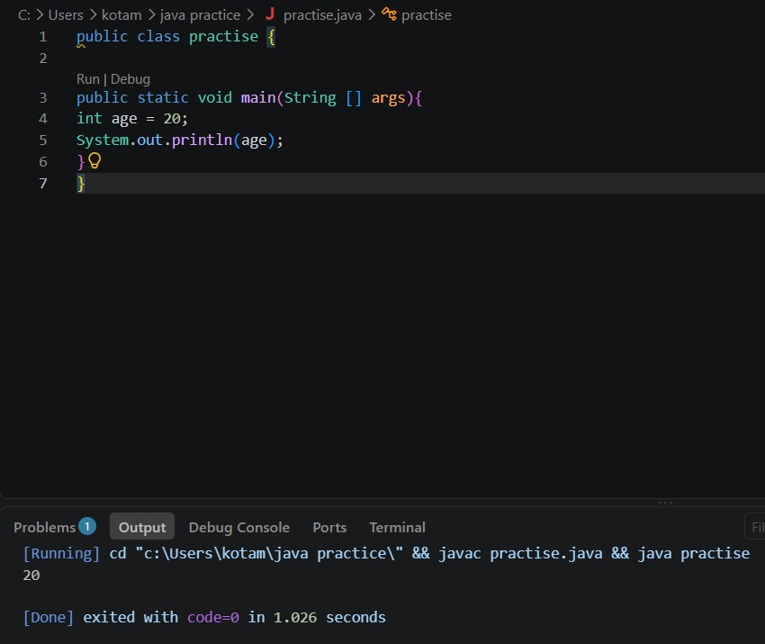

12.Name
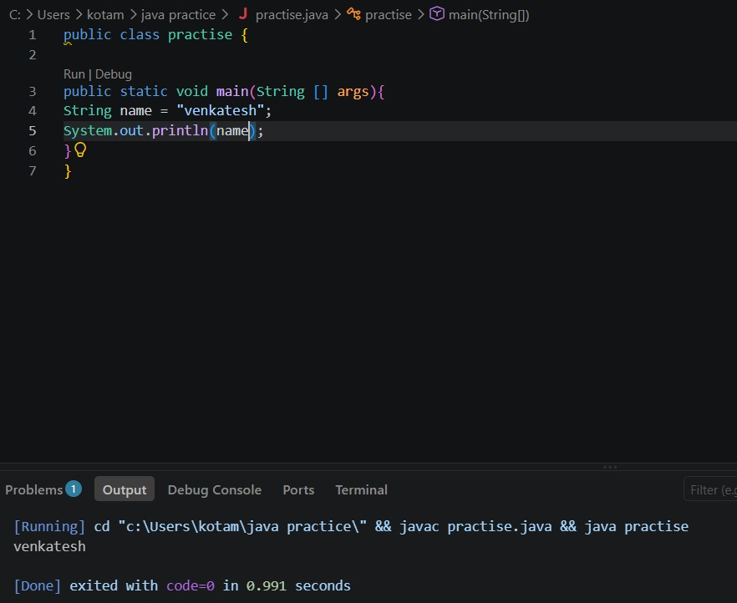

13.Salary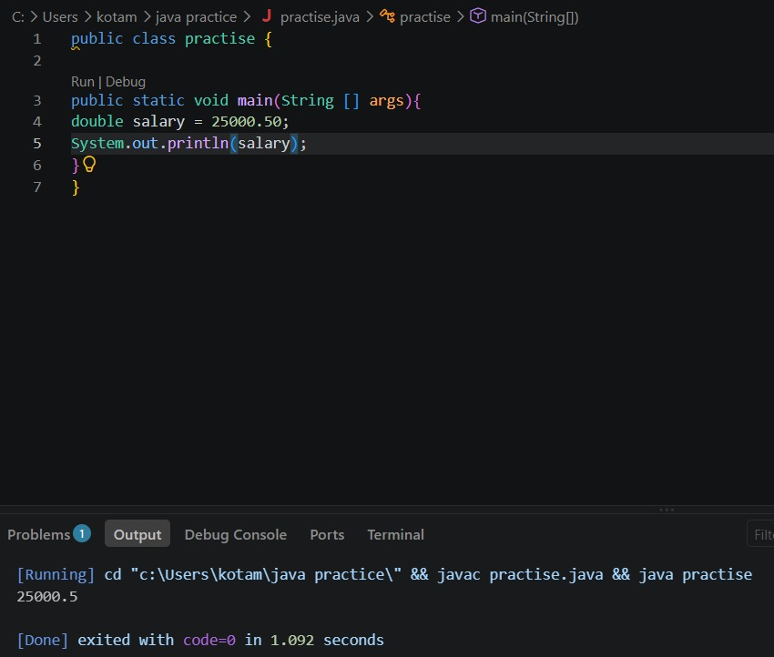
14.Sum of two numbers
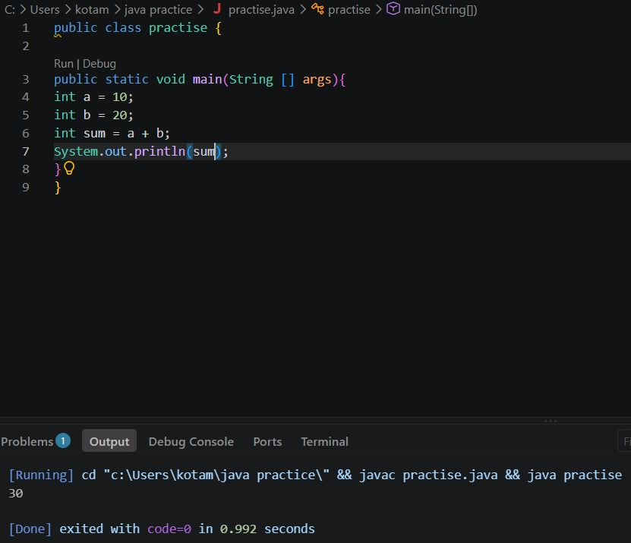
15.substraction
